Project Executable Files

Date | 15/07/2026
Team ID | xxxxxx
Project Name | CREDIT CARD APPROVAL
Maximum Marks | 3 Marks

Project Executable Files
This section requires submission of all executable and deployable files for your project. Ensure all files are properly organized, named, and uploaded to the specified submission platform. The evaluator must be able to run or deploy your solution using the provided files and instructions.

Step 1: Submission Checklist

S.No | Item to Submit | Submitted (Yes / No / NA)
1 | Complete source code (all files and folders) | YES
2 | README / Setup Guide (instructions to run the project) | YES
3 | requirements.txt / package.json / dependency file | YES
4 | Database schema / seed files (if applicable) | NA(no database used)
5 | Environment configuration file (.env.example or similar) | NA(if not used)
6 | Deployed application URL (if hosted) | YES
7 | APK / Executable binary (if applicable for mobile/desktop apps) | NA
8 | Dockerfile / Containerization config (if applicable) | NA
9 | Test files and test results | YES
10 | Demo video or walkthrough (if required) | YES

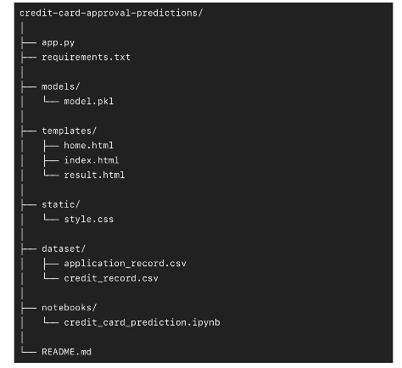

Step 2: File / Folder Structure
Provide an overview of your project's file and folder structure below:
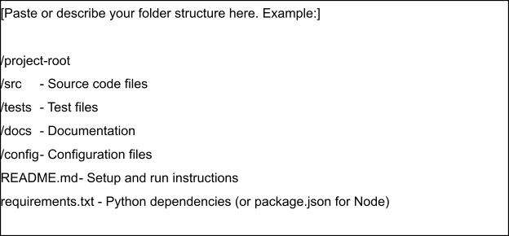

Step 3: Deployment / Access Details

Field | Details
Hosted / Deployed URL | https://credit-card-approval-predictions-4.onrender.com
Login Credentials (Demo) | mbhavanareddy1010@gmail.com
Platform / Hosting Provider | RENDER
Repository Link | https://github.com/ap24110011101/credit-card-approval-predictions
Demo Video Link | https://drive.google.com/file/d/1xjWtrm_TbqL9JGL9yB7AhBbw6R6FYBQU/view?usp=drivesdk

Step 4: Run Instructions
Provide clear, step-by-step instructions for the evaluator to run your project locally:
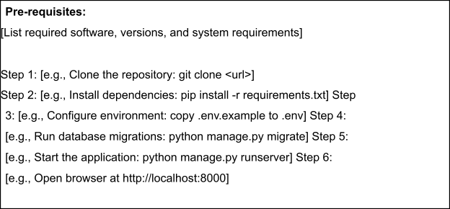

Step 5: Known Issues / Limitations

S.No | Known Issue / Limitation | Workaround / Status
1 | Model accuracy depends on the quality | Can be improved by training with larger
2 | Only predicts based on the available feautures | Add more relevant features to improve
3 | No user authentication | Can be added in a future version if required

